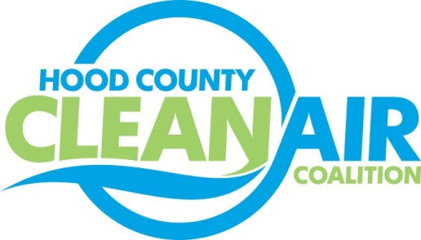
Meeting: Tuesday, August 6, 2013
American Town Hall
10:00-11:00 a.m.

Agenda

- Call Meeting to Order
- Updates - Michelle McKenzie
  - Conference calls
    - Air North Texas
    - CenSara (Central States Air Resources Agencies) Advance Program Organizations
- Rider 8 Projects
  - Work Plan Summaries – Michelle McKenzie
    - Staff funding for planning and administrative activities
    - Website maintenance
    - Outreach
  - NCTCOG Outreach Items – Mindy Mize
- Funding Opportunities – Shannon Stevenson
- Discussion / Vote Rider 8 Projects
- Adjourn

